**Research paper.**

**WHAT EXPLAINS LOW ACCESS**

**OF REFUGEES TO QUALITY EDUCATION?**

**Tresor Ndala Buzangu**

**Musizi University research Department.**

# Working paper April 1, 2024

**WHAT EXPLAINS LOW ACCESS**

# OF REFUGEES TO QUALITY EDUCATION?

**ABSTRACT**

This research delves into the multifaceted challenges confronting refugee communities in Uganda, with a particular focus on their access to education. It endeavors to provide valuable insights to decision-makers, notably the Musizi University team, to foster awareness and facilitate inclusive support mechanisms. Drawing from firsthand experiences as a refugee in Uganda in 2019, supplemented by direct interviews with refugees residing in diverse locales such as Nakivale, Kyangwali, and urban areas, this study illuminates numerous hurdles. These obstacles range from impediments to accessing higher education, difficulties faced by secondary school students in maintaining conducive study environments, to the struggles encountered by university students during the adaptation phase. Employing a comprehensive methodology that integrates literature review, qualitative and quantitative data collection, as well as personal narratives, this research not only identifies challenges but also proposes culturally sensitive interventions to address them.

## Keywords: refugees, economic violence, access to higher education, access to basic services.

1. **INTRODUCTION**

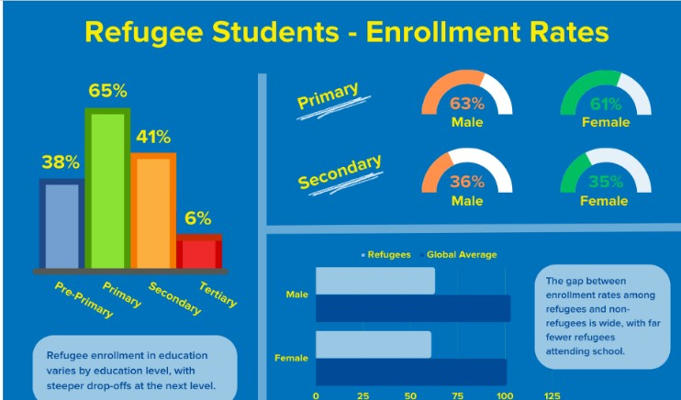According to UNHCR data, refugees have the lowest access to formal education compared to other minority groups. The gap between different school levels, such as secondary school and university, is striking. While 41 percent have access to secondary school, only 6 percent have access to higher education, underscoring the title of our article exploring the reasons behind refugees' limited educational access (UNHCR, n.d.).

Our research spans diverse locales like the Nakivale Refugee Camp, Kyangwali, and urban areas, where we conducted extensive interviews. Despite progressive policies, challenges persist, compounded by escalating refugee numbers and limited resources (UNHCR, 2016a). Nevertheless, amidst these challenges lie opportunities to improve refugee protection. Our paper aims to foster a more inclusive environment for refugees in Uganda through historical retrospectives, nuanced analyses, and actionable recommendations. We seek to shed light on refugee experiences and advocate for substantive measures that uphold their dignity, rights, and aspirations.

## LITERATURE REVIEW

The 1990s saw African states shift their asylum approach due to resource constraints and security concerns, fostering hope for better refugee education (Jones, 2013). This era emphasized global discourse on refugee integration and education opportunities, especially pertinent in Africa's protracted refugee situations (Kaiser, 2006). Uganda initially used encampment policies but later adopted a "Self-Reliance Strategy," granting freedom of movement and work rights alongside primary education access (KHIDDU-MAKUBUYA, 1994; Sandvik, 2011; Garimoi et al., 2005). However, persistent challenges remain, with refugee influxes and security threats hindering access to education (Ahimbisibwe, 2018). The conflict in South Sudan led to a massive refugee influx to Uganda, underscoring the need for sustained assistance beyond emergency responses (Paul et al., 2022). Uganda's experience highlights the importance of progressive policies amidst challenges, urging informed policymaking for enduring solutions to refugee education access (Jones, 2013; Kaiser, 2006; KHIDDU-MAKUBUYA, 1994; Sandvik, 2011; Garimoi et al., 2005; Ahimbisibwe, 2018; Paul et al., 2022).

## RESEARCH JUSTIFICATION AND RESEARCH QUESTIONS

Our research is propelled by an unwavering commitment to comprehensively apprehend the intricate challenges besieging refugee education within the context of Uganda. Motivated by a desire to transcend surface-level examinations, we aspire to delve deep into the root causes underpinning the educational disparities experienced by refugee communities. Central to our inquiry is the ethos of inclusivity, driving us to explore the obstacles and nuanced factors contributing to the educational disadvantage prevalent among refugee populations. Employing a participatory framework, we have endeavored to engage directly with refugee communities

spanning diverse backgrounds, focusing on discerning variations in educational challenges predicated upon factors such as ethnicity, nationality, and displacement history.

We have endeavored to illuminate common trends and discern lacunae within existing educational support structures through a meticulous blend of individual and group interviews. By intertwining personal narratives with organizational frameworks, we aim to illuminate the multifaceted barriers obstructing refugees' access to and progression through the educational continuum.

## Research Questions:

What are the primary obstacles impeding refugee access to education in Uganda, and how do these challenges manifest across different refugee communities?

How do variations in educational challenges among refugee populations based on ethnicity, nationality, and displacement history inform the design and implementation of targeted interventions?

How do existing educational support systems in Uganda fail to adequately address the diverse needs of refugee communities, and what actionable recommendations can be proposed to ameliorate these shortcomings?

## Results:

Thematic analysis of our data unveiled significant challenges impeding refugee access to education in Uganda. Foremost among these challenges is the pervasive issue of economic violence, which compels many young refugees to forego their educational aspirations in favor of engaging in activities aimed at securing immediate survival needs. This stark reality underscores

the harsh trade-offs that refugees often face in prioritizing education amidst dire socio-economic circumstances.

Our findings also highlighted the formidable barriers refugee populations encounter in accessing secondary and post-secondary education. These obstacles range from financial constraints, which render educational expenses prohibitive for many, to bureaucratic hurdles inherent in the refugee registration process. Such challenges exacerbate the already pronounced educational disadvantage experienced by refugee communities, perpetuating cycles of marginalization and hindering their ability to pursue academic opportunities.

Participant Voices:

Participants in our research shared poignant reflections on their struggles with accessing education:

**Tresor Ndala Buzangu:** " My story is a double story. Born into a family of a presidential guard soldier, I lived a good life from birth until 2018 when I graduated from school in a francophone system in my country, DR Congo. In 2017, I became the second Congolese to be admitted to the Yale Young African Scholars program in Ghana, led by Laura Kaub as the director.

Upon returning to my country, I graduated with high expectations and planned to apply to U.S. universities using the Common App. However, the war reached Beni, where many of my family members, including my mother, were killed, and my father was arrested. My aunt and I managed to reach Nakivale camp in Uganda. This experience led me to believe that being a refugee is a situation and not a person. Despite the drastic change from a good situation in Congo to a very difficult one in a refugee camp, my knowledge of six languages allowed me to work as an interpreter of French, Swahili, Lingala, Tshiluba, Kikongo, and some English.

I faced financial barriers that prevented me from pursuing a university education, but I did not give up hope. I continuously applied to U.S. universities, facing rejections from those with full financial aid and acceptances from those without it. This was my life from 2018 to 2022. Despite challenges accessing the internet in Nakivale camp, I successfully passed the tests and interview, securing admission to Ashesi University under the Mastercard scholarship.

I was very happy until I received a message stating that I needed to submit a passport by a certain deadline or lose the admission and scholarship. This was the most disappointing moment because I had always thought that getting a full scholarship meant being able to go and study. However, I realized that even a full scholarship was not enough in my situation, as obtaining a passport seemed impossible when affording food was difficult.

At that moment, a WhatsApp message of hope came from Laura Kaub, the former YYAS director and current director of the Duolingo Refugee Access to Higher Education program, telling me not to worry. She assisted me in obtaining a passport, enabling me to commence my university studies in 2022 at Ashesi University. The four gap years influenced my challenges at the beginning of my studies at Ashesi, as I was no longer involved in school and was doing small jobs in the camp to survive. However, thanks to the three months of a non-grading semester at Ashesi University, I was able to adjust both to the four years of gap and the transition from the French system to the English system.I believe that if all universities admitted refugee students and implemented a similar system to Ashesi University, it could help others in similar situations adjust before the graded semester ".

**Adelard**: "I fled conflict in the Democratic Republic of Congo and found refuge in Uganda, initially facing financial barriers to higher education due to the difference in educational systems. Fortunately, a refugee-led organization called CIYOTA in Kyangwali refugee camp supported me in accessing opportunities. Through their assistance and partnerships, I obtained a Mastercard scholarship to Ashesi University, where I am currently studying. Support for refugee-led organizations like CIYOTA can significantly enhance access to higher education for refugees, but sometimes I feel bad for my friends who reached out Kyangwali without some of their school documents which cause them to not have a chance to be admitted like me."

Kolodina: "I am a Rwandese refugee here, and I have spent almost all my life in Kyangwali refugee camp, where I completed my secondary school education. I became pregnant and had a child, which created many challenges for me in accessing higher education scholarships. As a mother, many scholarship offices questioned during interviews how I intended to balance studying with caring for my child. After facing many rejections only because they were not convinced, I will balance because some universities because my age was already beyond their age limit of admission. With resilience, I applied for a scholarship to DAFI Uganda, where, after sharing my story and demonstrating my interest and capacity to succeed in my studies if given

the chance, I was admitted. I am now studying at their university partner called Bugema University ."

**Frank**, shared his trauma in university: "Every day, I am haunted by the image of rebels raping my mother in my homeland. Unable to bear living with her in a refugee camp, I sought refuge in Kampala with support from my brother, who resettled in Canada 3 years ago. when studying in a university in Uganda without psychological help, I struggled to continue my studies but the depression was so high that I was unable to concentrate in my university studies consequently, I dropped out, I think many like me continue to even drop out of the scholarships because of lack of advising or counselor team adaptable to refugees, my story could have been differently if my university was having an adaptable team that could help me psychologically."

**John**: "I don't know where my father is. I only remember waking up in South Sudan amidst gunfire, with my mother taking me. By the grace of God, I am alive today, but I have no news of my father's whereabouts. Despite challenging situations, I did my best to study secondary school in Uganda and the refugee camp. Now, as I apply for scholarships to pursue university studies, many universities reject me. I believe these universities do not consider my story; they only compare my GPA with applicants who studied under better conditions, resulting in rejection, and others rejected me because I did not have one of my school documents when applying ."

**Antoine**, a Burundian refugee in Nakivale camp, recounted familial pressure to not apply for scholarships: "I was studying in Kabahinda with a very high GPA, but my father prohibited me to apply for scholarships for Kenya (USIU-Africa), Rwanda( ALU) and Ghana(Ashesi university ), my father raised two reasons the first one He believes education is useless for

refugees, citing his own experience of graduating in a very good university without job prospects and the second reason he believes that the family will get resettlement offer from UNHCR which if I am outside of Nakivale camp may cause all the family to not travel for the third country. Despite my passion for education, I cannot apply for scholarships as my father prohibited me."

**Jeane**: "I believed there was assistance for female students' menstrual needs in the camp. However, sometimes I miss school due to menstruation. I understand that all refugees face challenges in studying, but I believe female refugees face additional hurdles, such as the need for sanitary pads. I hope we can receive assistance in the future to improve our productivity in school and also I am always concerned to see my friends being rejected to even study high school like me because they lost their school documents in DRcongo when trying to save their lives."

**AbdulKarim**, a Somali refugee from Nakivale camp: "We have only one secondary school recognized by the state, Kabahinda, which is located far from the camp. I must walk around four hours to reach the school. Overcrowding is an issue within the school, making it difficult for lecturers to address students' needs adequately."

## Dataset:

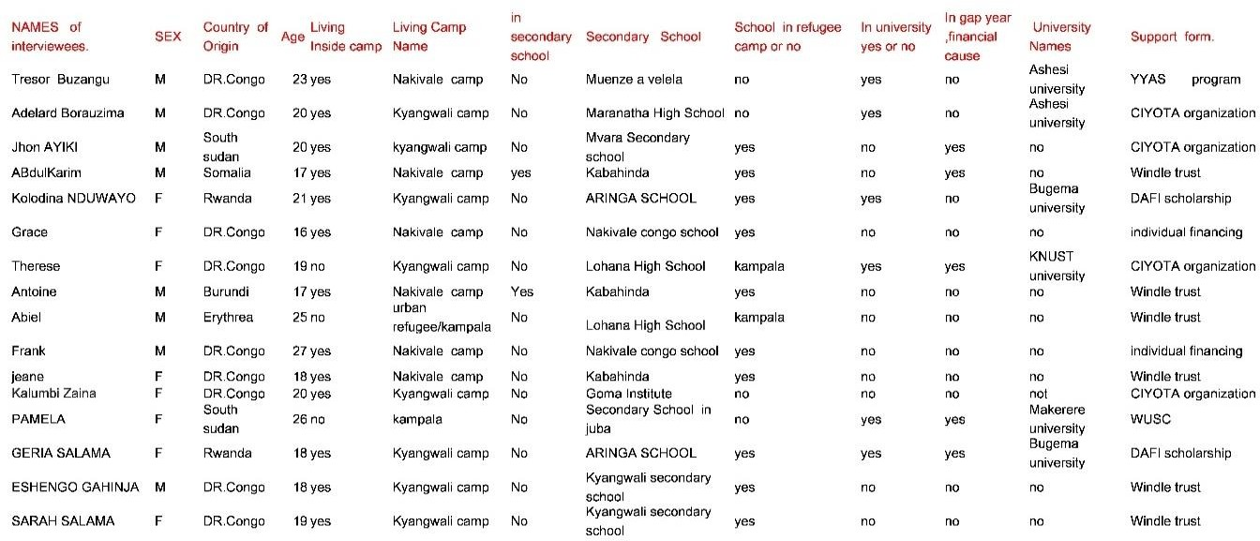

1. **DATA ANALYSIS**

Our data analysis revealed distinctive insights into the educational journeys of interviewed refugees, delineating three principal groups based on their educational status and the challenges faced. Among the 16 interviewees, the majority—13 individuals—resided within refugee camps, underscoring the prevalence of challenges within these environments.

:

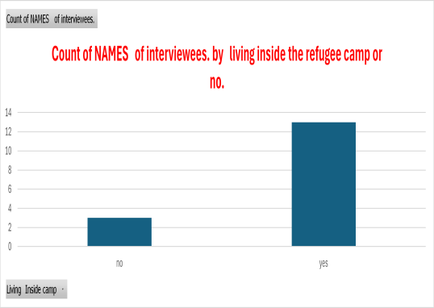

During the collection of data, we got three principal insights groups of interviewed refugees: the group of four refugees who have passed already through all the challenges: Tresor, Adelard, Kolodina, and Frank (dropped out) and are studying in the university where one lacking psychologically support dropped out, the second group is the group of refugees who are done with secondary school but meeting challenges to get access to university where we recorded two interviews: John and Antoine and the last group is the group of the refugees who are still studying secondary school in the refugee camp and meeting challenges in the refugee camps where we recorded two interviews: Jeane and Abdul Karim.

The data further reveals distinct challenges and barriers encountered by each group of interviewed refugees that I grouped into three principal groups: the refugees who have already succeeded in accessing university, those who finished high school, but they cannot afford

university, they are in a gap year currently and those who are still studying secondary school in Uganda:

University Students: Tresor, Adelard, Kolodina, and Frank (who subsequently dropped out) represent the cohort of refugees who have successfully transitioned from secondary school to higher education institutions. Tresor and Adelard's access to scholarships through external programs like the Yale Young African Scholars program and CIYOTA Organization exemplifies the pivotal role of external support mechanisms in facilitating educational opportunities. Kolodina's resilience in navigating familial and institutional barriers underscores the importance of individual determination. However, Frank's case underscores the critical need for comprehensive psychological support services, as untreated trauma can significantly impede academic success and mental well-being.

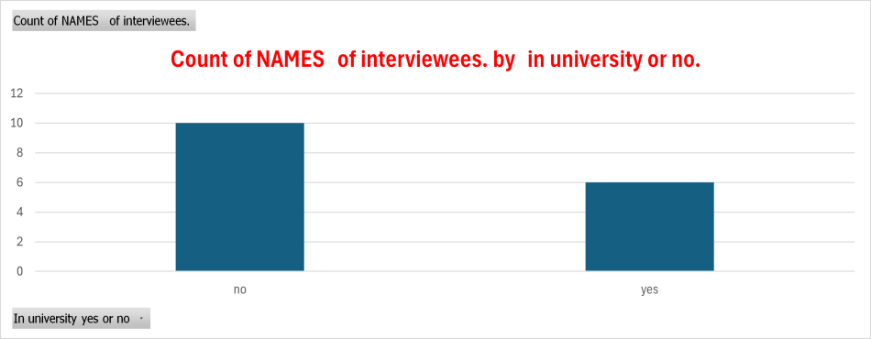

Secondary School Graduates Facing Access Barriers: John and Antoine exemplify refugees who have completed secondary education but encounter obstacles in accessing university opportunities. John's frustration highlights systemic flaws in the admissions process, emphasizing the need for more inclusive evaluation criteria considering refugees' unique circumstances.

Antoine's situation underscores the influence of familial expectations on educational choices, necessitating culturally sensitive support interventions that engage families.

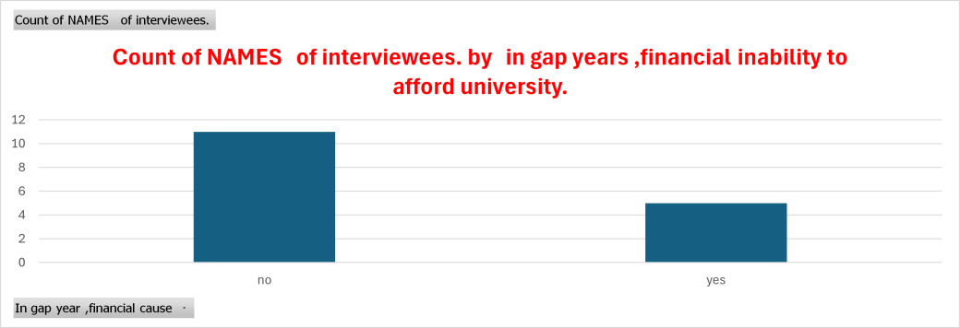

Secondary School Students in Refugee Camps: Jeane and AbdulKarim are still studying in secondary school within refugee camps, facing distinct challenges related to access and quality of education. Jeane's struggle with menstrual hygiene underscores gender-specific barriers faced by female refugees, necessitating targeted interventions to address these needs. AbdulKarim's experience sheds light on infrastructural and logistical challenges within refugee camp schools, impacting the overall learning environment and educational outcomes.

1. **RECOMMENDATIONS AND CONCLUSION**

Drawing upon participatory methods informed by personal experiences and interviews with approximately 15 refugees facing educational challenges in Uganda, alongside insights gained through an internship at CIYOTA Organization supported by the Ashesi Mastercard Scholarship, this study sheds light on the obstacles confronting refugee students from Congo,

Rwanda, and South Sudan in accessing higher education in Uganda.

Based on the challenges articulated by refugees during interviews, the following recommendations are proposed:

**Enhancing Language Support and School Documentation Retrieval from Country of Origin:**

* Provide comprehensive language support services, including translation assistance and language-specific resources, to accommodate the diverse linguistic backgrounds of refugee students, as exemplified by the language barriers faced by participants like Kolodina.
* Collaborate with educational institutions and organizations to develop language proficiency programs tailored to the needs of refugee students transitioning to English-medium education, akin to the language support provided to Tresor Ndala Buzangu through the Yale Young African Scholars program.
* Implement an AI-Powered Refugee Document Retrieval and Verification System to address documentation challenges. This system will facilitate the retrieval and verification of academic records from refugees' countries of origin using advanced AI and blockchain technology. By incorporating features such as automated document requests, real-time tracking, and AI-based validation, the system will streamline the process and provide refugees with essential documentation quickly and securely.

## Tailored Support for Diverse Educational Backgrounds:

Offer personalized support and guidance to refugee students with varied educational backgrounds, considering factors such as duration of time spent in refugee camps and differences in educational systems between home countries and Uganda, as evidenced by the challenges encountered by John and Antoine in accessing university opportunities.

Develop bridging programs or transition courses to facilitate the integration of refugee students into the Ugandan educational system and address any learning gaps, as observed from the diverse educational experiences of participants like Jeane and AbdulKarim.

## Facilitating Access to Scholarships:

Increase awareness of available scholarships among refugee communities through targeted outreach campaigns and information dissemination, drawing from the successful experiences of Tresor Ndala Buzangu and Adelard in accessing scholarship opportunities.

Provide comprehensive support services for scholarship application processes, including assistance with essay writing, interview preparation, and navigating online application platforms, addressing the challenges highlighted by Kolodina and Frank.

## Addressing Socio-Economic Barriers:

Implement financial assistance programs to alleviate socio-economic challenges faced by refugee students, including support for application fees, tuition, and study materials, in response to the experiences of Frank and other participants confronting economic constraints.

Advocate for policies that promote economic empowerment and job opportunities for refugee communities, enhancing their financial stability and ability to pursue higher education, as underscored by various participants, including Grace's observations on limited job opportunities for refugees.

## Collaborative Approach and Institutional Support:

Foster collaboration among government agencies, non-governmental organizations, educational institutions, and refugee-led organizations to develop holistic support systems for refugee students, leveraging the partnerships exemplified by Adelard's support from CIYOTA Organization and the Ashesi Mastercard Scholarship.

Establish institutional mechanisms within educational institutions to address the unique needs of refugee students, including counseling services, mentorship programs, and cultural sensitivity training for staff, aligning with the need for adaptable support highlighted in Frank's experience of struggling with psychological trauma without adequate support.

**In conclusion**, these recommendations, rooted in the experiences and challenges voiced by interviewees, seek to address the obstacles encountered by refugee students in Uganda and foster a more inclusive and supportive environment conducive to their academic success. By adopting a collaborative and targeted approach, stakeholders can work towards dismantling barriers, enhancing access to higher education, and empowering refugee communities to realize their educational aspirations and contribute meaningfully to society.

# REFERENCES

Dryden-Peterson, S. (2003). *EDUCATION OF REFUGEES IN UGANDA: RELATIONSHIPS BETWEEN SETTING AND ACCESS*.

https://yorkspace.library.yorku.ca/server/api/core/bitstreams/4c9e3bac-6a6d-43f9-8149- 5dd0b03af0db/content

Ezard, N., Oppenheimer, E., Burton, A., Schilperoord, M., Macdonald, D., Adelekan, M., Sakarati, A., & van Ommeren, M. (2011). Six rapid assessments of alcohol and other substance use in populations displaced by conflict. *Conflict and Health*, *5*(1), 1. https://doi.org/10.1186/1752-1505-5-1

Garimoi Orach, C., & De Brouwere, V. (2005). Integrating refugee and host health services in West Nile districts, Uganda. *Health Policy and Planning*, *21*(1), 53–64. https://doi.org/10.1093/heapol/czj007

Jones, W. (2013). UNHCR in Uganda: better than its reputation suggests. *Forced Migration Review*, *44*(44), 81–83.

Kaiser, T. (2006). Between a camp and a hard place: rights, livelihood and experiences of the local settlement system for long-term refugees in Uganda. *The Journal of Modern African Studies*, *44*(4), 597–621. https://doi.org/10.1017/s0022278x06002102

KHIDDU-MAKUBUYA, E. (1994). The Legal Condition of Refugees in Uganda. *Journal of Refugee Studies*, *7*(4), 402–410. https://doi.org/10.1093/jrs/7.4.402

UNHCR. (n.d.). *Five Takeaways from UNHCR’s 2023 Education Report*. Www.unrefugees.org. https:/[/www.unrefuge](http://www.unrefugees.org/news/five-takeaways-from-unhcrs-2023-education-report/)e[s.org/news/five-takeaways-from-unhcrs-2023-education-report/](http://www.unrefugees.org/news/five-takeaways-from-unhcrs-2023-education-report/)

**Research on Refugee Education in Kenya**

Our ethnographic research in Kenya focused on refugee education, largely facilitated by my status as a YALI alumnus. This connection helped me establish a strong collaboration with my colleague Robert, a trainer at the Osun Hub. Robert played a crucial role in gathering testimonies from refugees currently living in Kakuma, which I will now report. Additionally, my discussions with Laura Kaub, comparing higher education opportunities for refugees in Uganda and Kenya, further informed our research.

As we did in Uganda, we will continue to let refugees' voices be heard. However, to avoid redundancy, we will focus on reporting testimonies that highlight challenges distinct from those in Uganda. This approach ensures a well-synthesized research book that does not repeat similar issues.

Testimonies:

Robert: "I completed all my studies here in Kakuma Refugee Camp. The overcrowded classrooms, the long distance between my home and the school, and the necessity of working to support my family, as my mother is too weak to work, have caused me immense hardship. As a result, my grades suffered in the Kenyan national exams. Despite the numerous educational initiatives here, I was excluded from many because of my low grades, even though there were extenuating circumstances behind my academic performance. The education system within the camp is not comparable to that outside the camp, and it shouldn’t be treated as equal."

Ahadi: "I was a refugee in Uganda, specifically in Nakivale Refugee Camp. There, I faced challenges in pursuing higher education. Having studied in Congo, I found life in Nakivale even harder. The camp provided us with only $4 for food each month. This dire situation prompted me to leave Nakivale for Kakuma. Upon arriving here, the situation improved slightly, as I encountered many NGOs offering scholarships and educational opportunities. However, my difficulties continued. Not only had I completed my high school education in French rather than English, but the grades and exams required for scholarship eligibility were also a barrier. I couldn’t meet the standards, and until now, I have watched others benefit from opportunities while I remain excluded."

John: "I am passionate about artificial intelligence because I believe it can solve the educational challenges faced by refugees in the camp. Students with internet access and support from the Osun Hub are thriving in online studies, which helps them become more competitive in national and international exams like SAT or the Duolingo English Test."

Nestor: "I am studying here in Nairobi, but as a refugee, I have faced significant stigma. This led me to stop mentioning my refugee status because the local population does not treat refugees kindly, unlike in Uganda, where refugees are almost treated like citizens. Unfortunately, that is not the case here in Kenya."

Insights from Laura Kaub: "Compared to Dadaab Refugee Camp, Kakuma receives more attention from education access programs. In the past, some Dadaab scholarship beneficiaries would decide to work instead of continuing their studies once they reached Canada or the USA. Kakuma scholars, however, have earned the trust of facilitators by being more responsible. Furthermore, despite being home to Africa’s largest refugee population, Uganda has not received the attention it deserves. That is why, with the Duolingo Access Program, we prioritized integrating Uganda even before Kenya, despite the many education access initiatives already present in Kenya."